**Project Design Phase-II**

**Technology Stack (Architecture & Stack)**

|  |  |
| --- | --- |
| Date | 03 October 2022 |
| Team ID | PNT2022TMID52849 |
| Project Name | Project – Personal assistance for Seniors who are self reliant |
| Maximum Marks | 4 Marks |

**Technical Architecture:**

The Deliverable shall include the architectural diagram as below and the information as per the table1 & table 2

**Personal assistance for Seniors who are self-reliant**

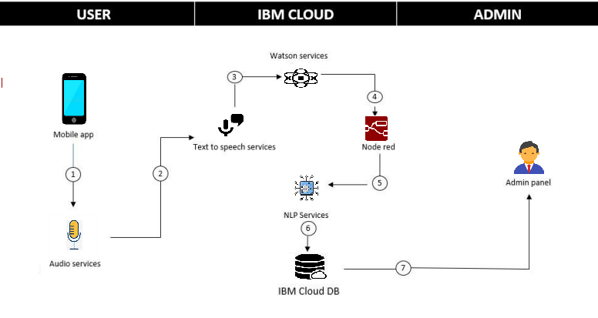

**Table-1 : Components & Technologies:**

|  |  |  |  |
| --- | --- | --- | --- |
| **S.No** | **Component** | **Description** | **Technology** |
|  | User Interface | Mobile Application | MIT App Inventor |
|  | Application Logic-1 | Logic for a process in the application | Python |
|  | Application Logic-2 | Logic for a process in the application | IBM Watson STT service |
|  | Application Logic-3 | Logic for a process in the application | IBM Watson Assistant |
|  | Database | Data Type, Configurations etc. | MySQL, Mango DB etc. |
|  | Cloud Database | Database Service on Cloud | IBM Cloudant |
|  | File Storage | File storage requirements | IBM Block Storage |
|  | Infrastructure (Server / Cloud) | Application Deployment on Local System / Cloud | Local, Cloud Foundry. |

**Table-2: Application Characteristics:**

| **S.No** | **Characteristics** | **Description** | **Technology** |
| --- | --- | --- | --- |
|  | Open-Source Frameworks | List the open-source frameworks used | Opencloud , Angular JS. |
|  | Security Implementations | List all the security / access controls implemented, use of firewalls etc. | Discretionary Acess Control(DAC) |
|  | Scalable Architecture | Justify the scalability of architecture (3 – tier, Micro-services) | SOA + EDA |
|  | Availability | Justify the availability of application (e.g. use of load balancers, distributed servers etc.) | Load balancers. |
|  | Performance | Design consideration for the performance of the application (number of requests per sec, use of Cache, use of CDN’s) etc. | 5 Request per plan |

**References:**

[**https://www.atlassian.com/agile/tutorials/burndown-charts**](https://www.atlassian.com/agile/tutorials/burndown-charts)

[**https://www.atlassian.com/agile/project-management/estimation**](https://www.atlassian.com/agile/project-management/estimation)

[**https://rb.gy/tqjby5**](https://rb.gy/tqjby5)

**https://rb.gy/inpczs**